Approved by
Resolution of UMP JSC Board of Directors
No. 17 dd. 29.12.2017

Agreed by Resolution of UMP JSC Board Protocol No. 55/1061 dd. 06.12.2017

UMP JSC Stakeholders’ Map

Ust-Kamenogorsk, 2017

This UMP JSC Stakeholders’ Map has been developed according to the Company corporate management Code and best world practice standards.
UMP JSC Stakeholders’ Map shall be used and implemented in order to form the constructive relations both with external and with internal parties of concern, make considerable impact on the society sustainable development. The effective system of interaction with the parties of concern provides necessary conditions for the creation of a long-term cost, achievement of strategic targets and formation of the positive reputation of the society.
To construct the effective interaction with the parties of concern it is a basic principle of "inclusiveness" meaning considering and accounting of the interests and requirements of all parties of concern.
During interaction among UMP JSC and the parties of concern the society aspires to co-operate with the interested parties based of following principles:
- Importance – a correct estimation of the importance of problems for the interested parties;
- Completeness – understanding of importance of consequences of activity of the society and that the interested parties think of it;
- Response – demonstration by the society of an adequate answer.

UMP JSC Stakeholder’s Map

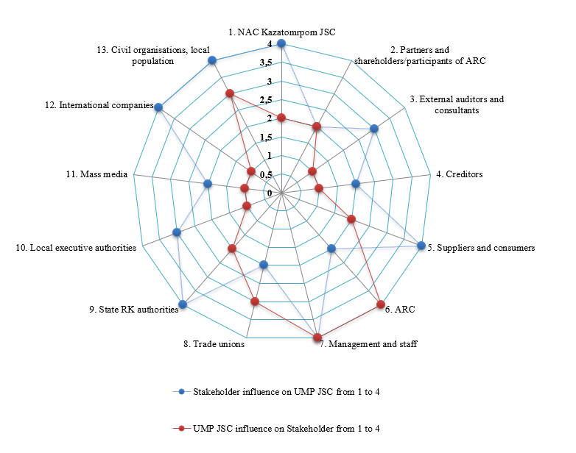

Stakeholder in relation to UMP JSC | Stakeholder’s interest toward UMP JSC | Form of a dialogue between stakeholder and UMP JSC | Influence by stakeholder on UMP JSC, from 1 to 4 | Influence by UMP JSC on stakeholder, from 1 to 4
- Sole shareholder of UMP JSC - NAC Kazatomprom JSC | - Increase of the ling-term cost of UMP JSC.  - Perform UMP JSC development Strategy within the frames of implementing global strategy of NAC Kazatomprom.  - Dividends receipt.  - Social program performance.  - Mid-term development plan performance. | - Resolution by a sole Shareholder of UMP JSC (resolutions by NAC Kazatomprom JSC Board of Directors and the Board, orders by NAC Kazatomprom JSC Chairman of the Board).  - Resolutions by UMP JSC Board of Directors.  - Joint work teams.  - Meetings, discussions and other. | 4 | 2
2. Partners and shareholders / participants of the affiliate and related companies of UMP JSC (ARC) | - Increase long-term cost of joint ventures.  - Receiving income (dividends) from the joint management.  - Production and investment program performance.  - Social programs performance.  - Mid-term development plan performance. | - Statutory agreements.  - Resolutions by GMM (GMS).  - Resolutions by SB (BD).  - Resolutions by joint consulting and advisory authorities.  - Joint work teams.  - Joint audits.  - Meetings, discussions.  - Correspondence exchange on ARC activity issues. | 2 | 2
3. External auditors and consultants | - IFRS standards observance.  - Confidence of UMP JSC financial reporting.  - Follow the recommendations by external auditor.  - Timely payment according to contracts. | Contracts, reports and letters to the Management. | 3 | 1
4. UMP JSC creditors | - Timely return of main debt in full and fee receipt.  - Financial stability of UMP JSC. | - Business correspondence.  - Regular analytical meetings, discussions.  - Publishing information about UMP JSC in mass media. | 2 | 1
5. Suppliers and consumers | 1. Stability and safety of mutually beneficial cooperation.  2. Guarantee of fulfillment of mutual obligations under agreements/contracts.  3. Guarantee of high quality (stability, reliability, security and continuity of supply) of products/services.  4. Regular updating and improvement of UMP JSC activities. | 1. Customer feedback system.  2. Conducting meetings, negotiations.  3. Signing of contracts, memorandums, agreements on strategic cooperation. | 4 | 2
6. UMP JSC subsidiaries and affiliates | - Confidence in financial support for implementation of a plan.  - Fulfillment of investment and social plans/obligations by subsidiaries and affiliates with the support of UMP JSC.  - Support to UMP JSC in sustainable development. | 1. Statutory agreements.  2. Resolutions by GMM (GMS).  3. Resolutions by SB (BD).  4. Correspondence on subsidiaries and affiliates activity.  5. Information/reports on implementation of production, investment and social plans/obligations sent to UMP JSC. | 2 | 4
7. Management and personnel | - Results, achievements and development prospects of UMP JSC.  - Personnel and social policy of UMP JSC.  - Involvement and development prospects of the personnel.  - Activities on financial and non-financial motivation.  - Terms and conditions of Collective Agreement.  - Comply with legislation provisions and regulations with regard to labor legislation of the Republic of Kazakhstan.  - Arrangement of favorable conditions (motivation) for retention and recruitment of highly-qualified workers. | - Operational, production meetings, daily briefings and other meetings.  - Oral appeals.  - Channels of internal communications.  - Statements and requests. | 4 | 4
8. Trade unions | - Compliance with statutory obligations by the employer with regard to employees.  - Protection of employees’ rights and interests. | - Discussion and approval of Collective Agreement.  - Meetings and encounters of trade union members with UMP JSC management. | 2 | 3
9. Governmental authorities of the Republic of Kazakhstan | - Compliance with the legislation and regulations of the Republic of Kazakhstan by UMP JSC and its subsidiaries and affiliates.  - Obtaining of time-sensitive and reliable information.  - Promotion of competition.  - Issue of conclusion with respect to further activity on specific commodities market.  - Fulfillment of tax obligations into the budget to the full extent and within the terms established.  - Fulfillment of international obligations of the Republic of Kazakhstan.  - Granting of rights for subsurface use.  - Licensing of certain activities.  - Fulfillment of licensing and contractual obligations by UMP JSC subsidiaries and affiliates.  - Development of atomic engineering and industry in the Republic of Kazakhstan. | - Request of reporting based on the results of UMP JSC financial and operational activities.  - Requests of the governmental authorities on different directions of UMP JSC activity.  - Distribution of information on introduction of amendments and additions to the laws and regulations of the Republic of Kazakhstan.  - Approval of contract for subsurface use, certificate of governmental registration for subsurface use right.  - Verification of licensing and contractual obligations fulfillment by UMP JSC. | 4 | 2
10. Local executive authorities | - Increase of tax proceeds into the local budgets.  - Fulfillment of contractual obligations with regard to expenses for social services.  - On-time and high-quality implementation of social projects.  - Increase (retention) of work positions.  - Compliance with the legislation of the Republic of Kazakhstan with regard to industrial, radiation and nuclear safety. | - Memorandums of cooperation between local executive authorities and UMP JSC for the purpose of support and development of the regions’ social services.  - General agreements between local executive authorities and UMP JSC on financing of regions’ social services. | 3 | 1
11. Mass media | - Obtaining of time-sensitive and reliable information on UMP JSC activity:  - on industrial safety;  - on quality of output products;  - on financial indicators;  - on implementation of common projects;  - on prospects of industry development=. | - Contracts for rendering of services on publication of information (articles, stories) on UMP JSC activity.  - Participation in press-conferences, briefings, presentations, press tours to the industrial facilities, distribution of press releases, photographing and video recording. | 2 | 1
12. International organizations | - Compliance with Kazakhstan and international (ratified and unratified in the Republic of Kazakhstan) standards/regulations on provision of industrial, radiation and nuclear safety as well as management systems requirements.  - Openness and transparence of activity.  - Participation in preparation/review of the drafts of normative legal documents. | - Participation in common projects.  - Correspondence on issues exercising.  - Preparation of expert findings, proposals and comments to the drafts of normative legal documents.  - Performance of verifications and audits. | 4 | 1
13. Public organizations, local population | - Financing of social programs.  - Rendering of charity support and sponsor support.  - Public hearings. | - Holding of public hearings.  - Informing on current activity.  - Letters (appeals) addressed by UMP JSC. | 4 | 3

GMM (GMS) – General Meetings of Members (General Meetings of Shareholders);
BoS (BoD) – Boards of Supervisors (Boards of Directors).

